Name: _______________________________________________
Foundation Unit 3 topic test
Date:
Time: 50 minutes
Total marks available: 49
Total marks achieved: ______

Questions
Q1.
The table shows information about 5 cameras.
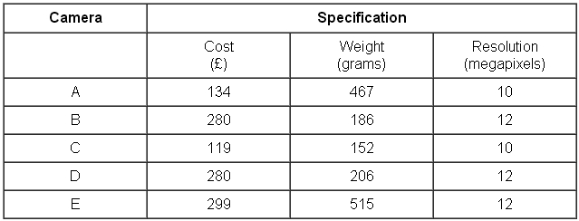
(a) Which of these cameras costs the most?
..............................................................................................................................................
(1)
Two of these cameras cost under £200
(b) Which of these two cameras weighs the most?
..............................................................................................................................................
(1)
The pictogram shows the number of cameras sold in a shop in week 1, in week 2, in week 3 and in week 4.
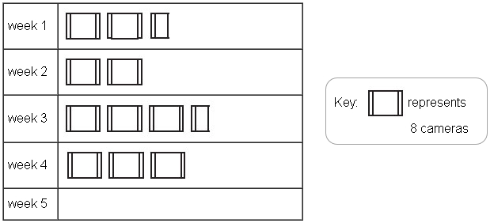
(c) How many cameras were sold in week 2?
..............................................................................................................................................
(1)
(d) How many cameras were sold in week 3?
..............................................................................................................................................
(1)
12 cameras were sold in week 5
(e) Show this on the pictogram.
(1)
(Total for Question is 5 marks)
Q2.
The table gives information about the results of the matches a football team played.
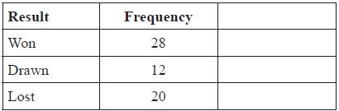
Draw an accurate pie chart to show this information.
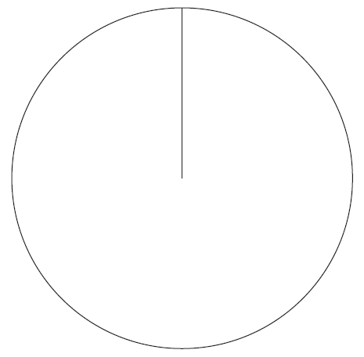
(Total for Question is 4 marks)

Q3.
Here is a list of all the coins in Amira's purse.
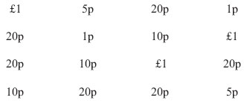
Complete the table for this information.
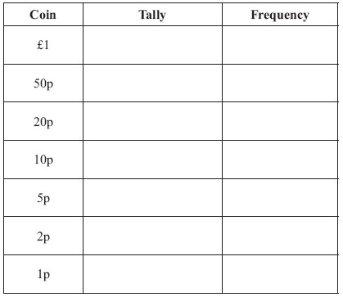
(Total for Question is 2 marks)

Q4.
Felicity asked 100 students how they came to school one day.
Each student walked or came by bicycle or came by car.
49 of the 100 students are girls.
10 of the girls came by car.
16 boys walked.
21 of the 41 students who came by bicycle are boys.
Work out the total number of students who walked to school.

..............................................................................................................................................
(Total for Question is 4 marks)
Q5.
The diagram shows the average midday temperature in Tenerife and in London during 6 months.
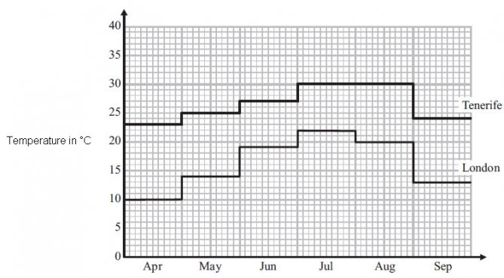
(a) During which two months is the average midday temperature in Tenerife the same?

..............................................................................................................................................
(1)
(b) During which month is there the greatest difference between the average midday temperatures in London and in Tenerife?

..............................................................................................................................................
(1)
(c) Write down the average midday temperature in May for London.

. . . . . . . . . . . . . . . . . . . . . . °C
(1)
(d) In September, what is the difference between the average midday temperatures in London and in Tenerife?

. . . . . . . . . . . . . . . . . . . . . . °C
(2)
(Total for Question is 5 marks)

Q6.
The pie charts show some information about the numbers of matches won, drawn and lost by a cricket team and by a hockey team last year.
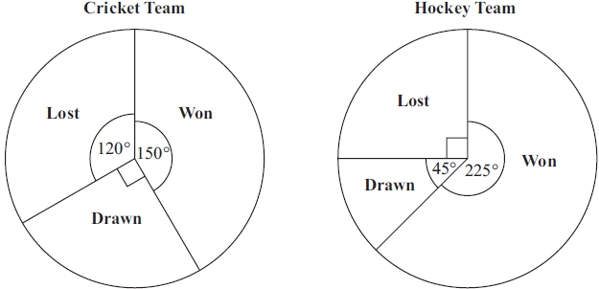
The cricket team won 15 matches.
(a) How many matches did the cricket team lose?

..............................................................................................................................................
(2)
(b) Which team won the most matches last year?
Tick one box to show your answer.

Cricket | Hockey | Not enough information
Explain your answer.
..............................................................................................................................................
..............................................................................................................................................
..............................................................................................................................................
..............................................................................................................................................
(1)
(Total for Question is 3 marks)

Q7.
The list below shows the weight, in grams, of 15 baskets of strawberries.
193 | 200 | 207 | 211 | 198
189 | 218 | 195 | 206 | 189
223 | 190 | 207 | 205 | 212
Show this information in an ordered stem and leaf diagram.
You must include a key.

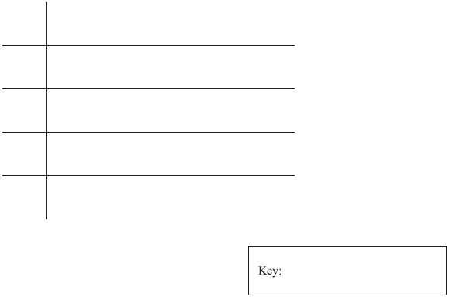
(Total for Question is 3 marks)

Q8.
The stem and leaf diagram gives the heights, in cm, of some potato plants.
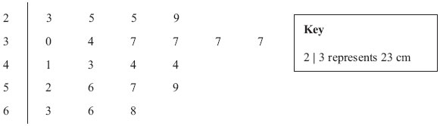
(a) Write down the greatest height.
..............................................................................................................................................
(1)
(b) Write down the mode.
..............................................................................................................................................
(1)
(c) Find the median.
..............................................................................................................................................
(2)
(Total for Question is 4 marks)

Q9.
Helen went on 35 flights in a hot air balloon last year.
The table gives some information about the length of time, t minutes, of each flight.
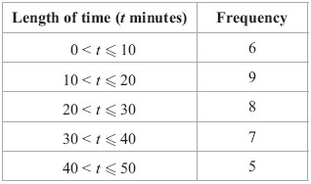
On the grid below, draw a frequency polygon for this information.
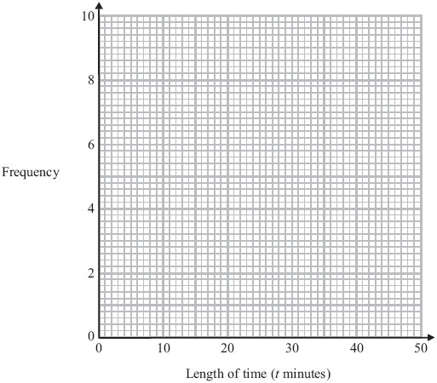

(Total for Question is 2 marks)

Q10.
Carlos has a cafe in Clacton. Each day, he records the maximum temperature in degrees Celsius (°C) in Clacton and the number of hot chocolate drinks sold.
The scatter graph shows this information.
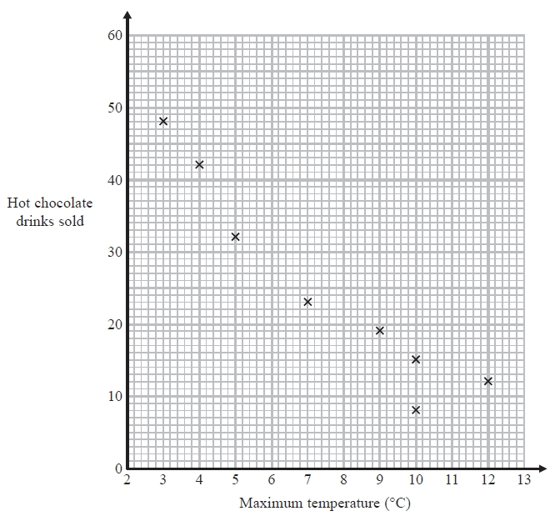
On another day the maximum temperature was 6 °C and 35 hot chocolate drinks were sold.
(a) Show this information on the scatter graph.
(1)
(b) Describe the relationship between the maximum temperature and the number of hot chocolate drinks sold.
.............................................................................................................................................
.............................................................................................................................................
(1)
(c) Draw a line of best fit on the scatter diagram.
(1)
One day the maximum temperature was 8 °C.
(d) Use your line of best fit to estimate how many hot chocolate drinks were sold.
..........................
(1)
(Total for Question is 4 marks)
Q11.
Beth recorded the temperature, in degrees (°C), inside her greenhouse every hour on one day.
The graph shows information about her results.
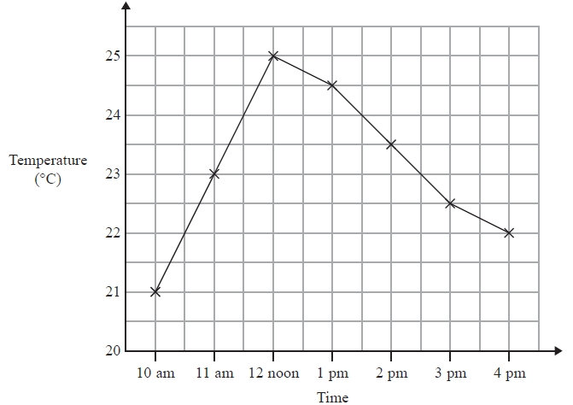
(a) Write down the temperature at 11 am.
............................°C
(1)
(b) Write down the highest recorded temperature.
............................°C
(1)
(c) Describe the change in temperature from 12 noon to 4 pm.

.............................................................................................................................................

.............................................................................................................................................
(1)
(Total for Question is 3 marks)
Q12.
Sam and Max work in a shop from Monday to Friday.
Sam draws a graph to show the number of TVs they each sell.
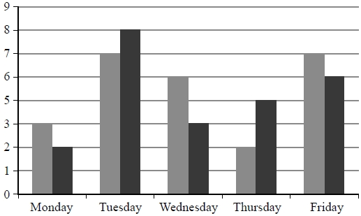
Write down three things that are wrong with this graph.
1
.............................................................................................................................................
.............................................................................................................................................
2
.............................................................................................................................................
.............................................................................................................................................
3
.............................................................................................................................................
.............................................................................................................................................

(Total for question = 3 marks)

Q13.
Amanda lives in Hanford.
She wants to go on a shopping trip to Middleton.
She is going to go by train.
Here is part of the train timetable from Hanford to Middleton and from Middleton to Hanford.
Hanford to Middleton
Hanford | 08 05 | 09 05 | 09 35 | 10 05 | 10 35 | 11 05
Market Down | 08 17 | 09 17 | 09 47 | 10 17 | 10 47 | 11 17
Kimble | 08 30 | 09 30 | 10 00 | 10 30 | 11 00 | 11 30
Treach | 08 39 | 09 39 | 10 09 | 10 39 | 11 09 | 11 39
Middleton | 08 48 | 09 48 | 10 18 | 10 48 | 11 18 | 11 48
Middleton to Hanford
Middleton | 13 11 | 13 42 | 14 11 | 14 42 | 15 11 | 15 42
Treach | 13 20 | 13 51 | 14 20 | 14 51 | 15 20 | 15 51
Kimble |  | 14 01 |  | 15 01 |  | 16 01
Market Down | 13 43 | 14 16 | 14 42 | 15 16 | 15 42 | 16 16
Hanford | 13 53 | 14 26 | 14 53 | 15 26 | 15 53 | 16 26
It takes Amanda 5 minutes to walk between her home and Hanford station.
She wants to have at least 4 hours in Middleton.
She wants to get back home by 4 pm that day.
Plan a schedule for Amanda's shopping trip.

 | Start time | Finish time
Home to Hanford station
Hanford station to Middleton station
Time in Middleton
Middleton station to Hanford station
Hanford station to home
(Total for Question is 5 marks)
Q14.
Jo and Liz work in the same shop.
One day, Liz starts work at 9.30 am and stops working 5 hours later.
Jo works from 11.30 am until 4.30 pm.
Work out the number of hours that Jo and Liz are working at the same time.
........................................................... hours
(Total for question = 2 marks)

Examiner's Report
Q1.
Over 95% of candidates correctly identified which camera cost most in part (a). In part (b) the success rate dropped to about 70% mainly because many candidates gave both A and C as the 2 cameras which cost less than £200 and did not go on to identify A as the heaviest.
Parts (c), (d) and (e) relating to the pictogram were all very well answered.

Q2.
This question was not well answered and was not even attempted by a good number of candidates. Many who did attempt this question had more than 3 sectors so could not gain any marks others just used the given values directly as degrees. Some candidates did manage to draw one angle correct but it was doubtful how they did this without any evidence of working out. Freehand lines were also in evidence and candidates need to be reminded that this can often lose marks as part of a freehand line could fall outside the accepted tolerance.
If all three angles were drawn they were usually correctly labelled, however, a small number of candidates showed all their working, drew correct angles and then placed the labels in the wrong sectors.

Q3.
Most candidates were able to use tallies to record the numbers of coins and complete the frequency column. Some candidates wrote the frequencies in the tally column and used the frequency column to record the total amount of money for each coin, and some gave their frequencies as sixteenths or with money notation.

Q4.
The majority of candidates were unsure of how to start tackling this question; many simply manipulated the figures given with no real purpose. Candidates who worked separately with boys and girls often gained some success and those candidates who put the given information into a two-way table usually gained full marks. Candidates should be encouraged to use such methods with questions of this type.
Many candidates found the 19 girls who walked to school, but then failed to simply add this to the given number of boys, often choosing instead to add it to 14 (boys who came by car). Other candidates simply added up all of the numbers given and subtracted from 100 or subtracted the listed numbers from 49.

Q5.
The first three parts of this question were answered quite well with a correct response from 72%, 63% and 88% of candidates, respectively. Part (d) was also well done though some lack of care was evident with a significant number of candidates either misreading the temperature scale or making an error in their arithmetic. The incorrect answer 10 was commonly seen. Candidates who wrote down the subtraction of their two temperatures were more likely to gain potential credit in such circumstances. Few did.

Q6.
A correct answer of 12 was seen more than it was not in part (a), 10 being the most popular incorrect answer seen. It was rare to see any working shown and so candidates usually earned the full two marks or no marks at all.
In part (b), 'Hockey' was selected as the team that won the more matches, candidates simply comparing the size of the respective sectors.

Q7.
There were many good answers to this with accurate stem and leaf diagrams and a key correctly filled in. A few candidates decided that the stem should be a single digit and so produced two rows, one starting with 1 and the other with 2. If a consistent key was shown then this was given 2 marks as the stem and leaf is not fully fit for purpose; normal practice is that the leaves are single digits. If there were errors in a nearly correct diagram, they tended to be with the number 8 from the 218.

Q8.
In part (a) most candidates could identify the greatest height, but some gave it as "8" or "6" rather than "68". In part (b) weaker candidates went for the median or the mean; but again some gave the mode as "7" rather than "37". In part (c) the mean was again common. Those trying to find the median found counting the numbers difficult, as evidenced by answers of 37 or 43.

Q9.
There remains a lot of confusion about frequency polygons. Weaker candidates confuse them with bar charts, or plot the points at the ends of the interval. Others plot them as if a scatter diagram, without joining the points. What to do at the ends is a further confusion, and some joint the two end points. Candidates who drew a bar chart gained some credit if the midpoints of the top of the bars was indicated, but no credit if the corners were used instead. Candidates who superimposed a polygon on top of the bar chart could get full marks.

Q10.
The point in part (a) was always plotted accurately if given. Part (b) was also well answered, the most common error in identifying a single point rather than a relationship (e.g. the most drinks were sold at the maximum temperature) or by giving a partial answer (e.g. negative rather than negative correlation). Too many in part (c) gave lines of best fit that were too far distanced from the points, or merely joined up each of the points. Whether or not a line of best fit was drawn, most students were able to give an answer in (d) that was reasonable, sometimes choosing to ignore their line and give a better answer using estimation.

Q11.
Usually a well answered question. However sometimes the answer given in (c) did not explicitly mention a downward or falling trend in temperatures.

Q12.
No Examiner's Report available for this question

Q13.
This question was well attempted by candidates who were scoring the full range of marks with candidates able to gain full marks. Candidates frequently drafted their responses before writing them on the table. Of the candidates who opted not to use the table many were able to gain marks, though it was rarer to see a fully correct response. The most common error was failure to leave a gap of 4 hours for shopping in Middleton. Weaker candidates were able to score 1 mark, usually for leaving at least 5 minutes walking time to the station, even if they confused by the timetables and unable to write correct start and finish journey times. Some candidates thought that they needed to convert to 12 hour clock times which, although not always an issue, in the main led to errors and lost marks. It was rare to see schedules, even incorrect ones, that finished after 4pm. Only a few candidates offered a fully correct schedule then went on to leave a gap of less than 5 minutes to walk home.

Q14.
Most students scored at least one mark for working out or using a correct duration of time, e.g. working out that Liz finished work at 2.30pm, and many went on to give the correct answer. In an attempt to find the number of hours between 11.30am and 2.30pm some students wrote down '11.30am, 12.30pm, 1.30pm, 2.30pm' and then gave the answer as 4 hours.

Mark Scheme
Q1.
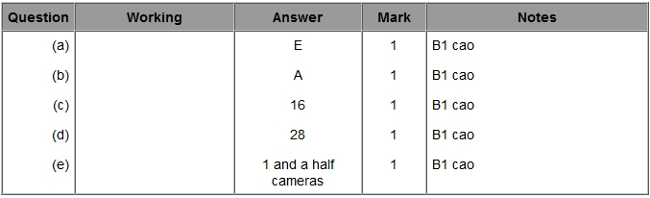

Q2.
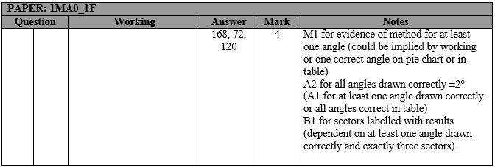

Q3.
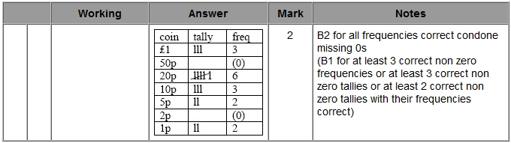

Q4.
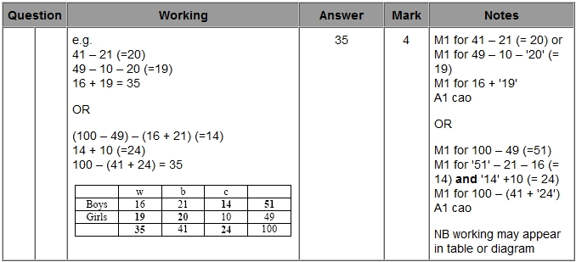

Q5.
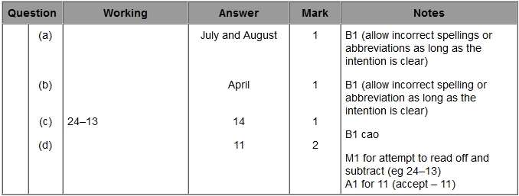

Q6.
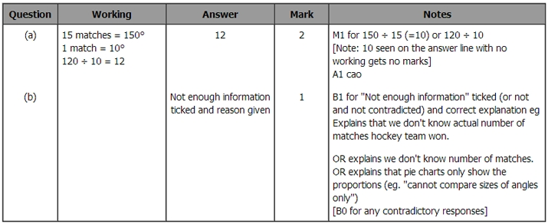

Q7.
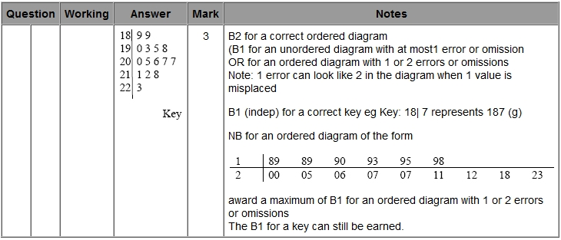

Q8.
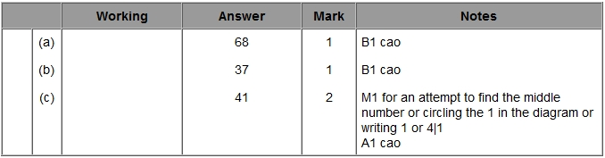

Q9.
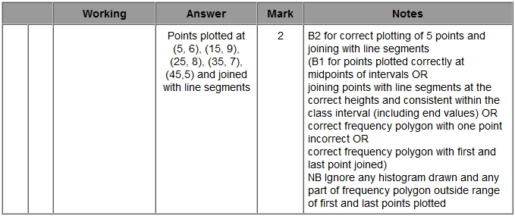

Q10.
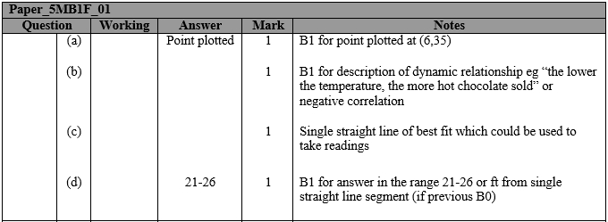

Q11.
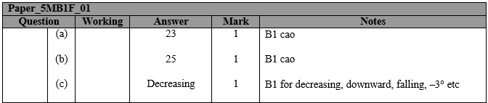

Q12.
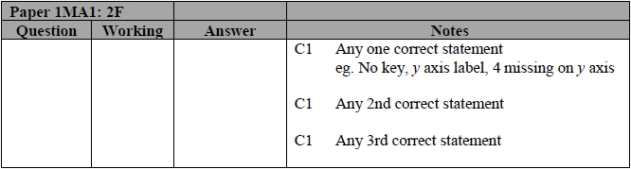

Q13.
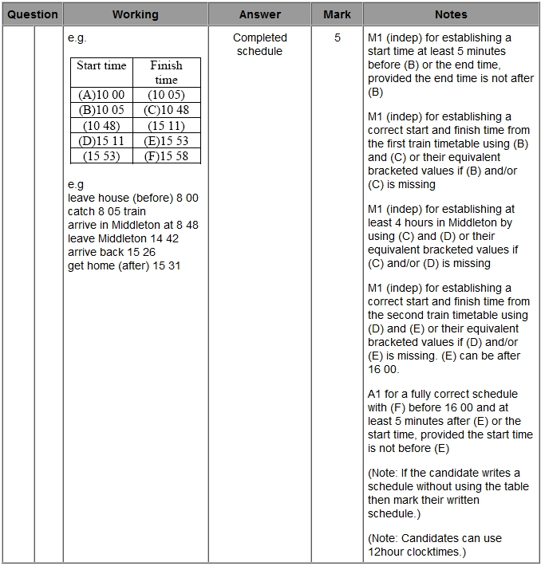

Q14.
